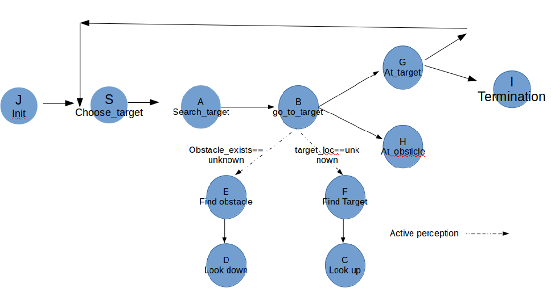
Behavior J
name: Init
preconditions:
Support
Termination: Initiated
Body: Initiate knowledge
resources

Behavior S
name: choose target
preconditions: there_are_targets
Support
Termination: fount_t==true
Body: choose target
resources

Bhavior A
name: search_target
preconditions
Support
Termination: fount_t==true
Body: Turn right, if found target update target_loc, found_t=true
resources

Bhavior B
name: go_to_target
preconditions
Support
Termination:distance(target_loc)<1 or no_obsticle==false
Body: drive stright
resources: wheels

Bhavior C
name:Look_up
preconditions cam_down
Support
Termination:cam_up==true
Body: turn camera up, when finished update cam_down and cam_up
resources: camera

Bhavior D
name: look_down
preconditions: cam_up
Support
Termination: cam_down==true
Body: turn camera down, when finished update cam_down and cam_up
resources

Bhavior E
name: find_obsticle
preconditions
Support
Termination: obsticle_exists==true or isneeded(resource(cam))
Body: Alloc[D], Update(obsticle_exists)
resources: cam

Bhavior F
name: find target
preconditions
Support
Termination: found_t or isneeded(resource(cam))
Body: Alloc[C], Update(goal_loc)
resources: cam

Bhavior G
name: at_target
preconditions
Support
Termination: there are targets has been updated
Body: update there_are_targets
vote between: S, I

Bhavior I
name: final state
preconditions: there_are_targets = FALSE
Support
Termination: printed
Body: print “final”
vote between: S, I

